**The Importance of Boundaries: How Work-Life Balance Affects Mental Health**

In today's fast-paced, interconnected world, the lines between work and personal life are often blurred. Technological advances have facilitated instant communication and constant accessibility, inadvertently causing disruptions to the delicate work-life balance.

This article explores the significance of boundaries in maintaining work-life balance and its impact on mental health. It also discusses the benefits, risks, and factors that companies should consider when aiming to cultivate a culture that fosters mental well-being.

## **The Work-Life Balance Conundrum**

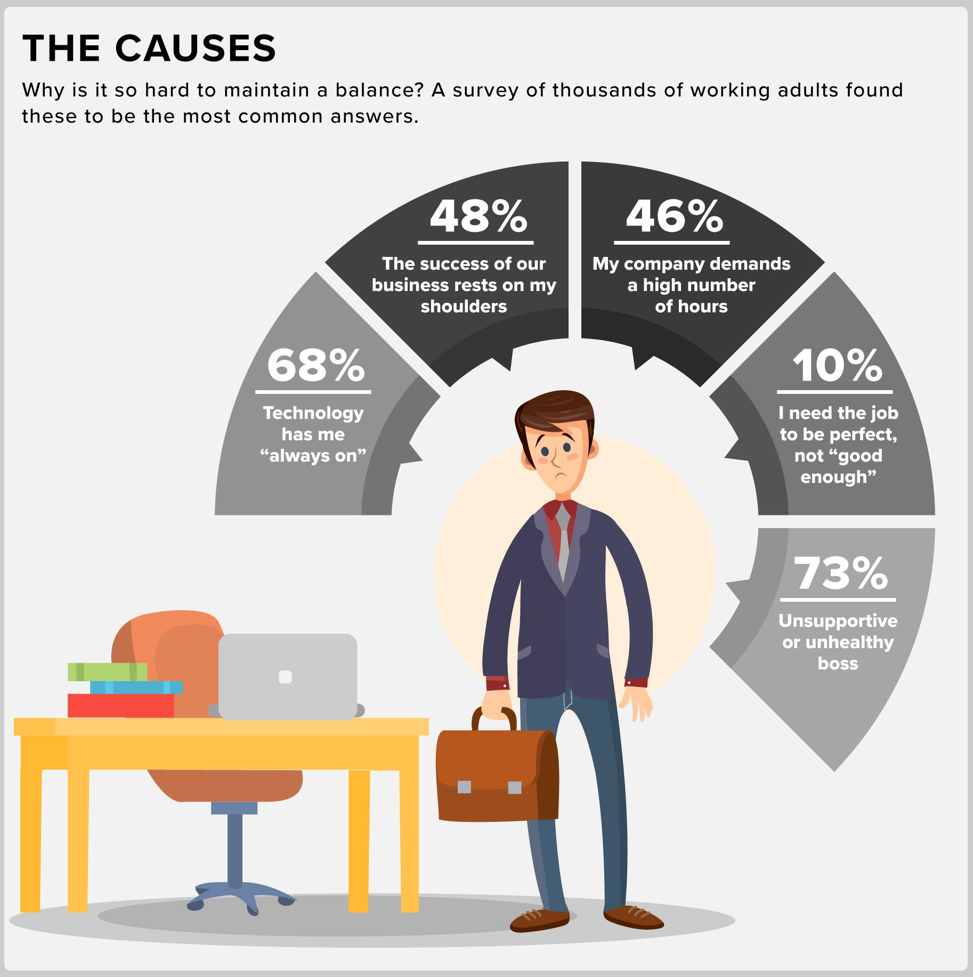

[Source](https://thewireboard.rewireinc.com/resources/blog/infographic-why-work-life-balance-is-difficult-why-we-need-to-pursue-balance-anyway)

Work-life balance essentially involves maintaining a harmonious equilibrium between professional obligations and personal commitments. A balanced work-life scenario ensures that individuals allocate equal importance to their career and personal growth, resulting in improved productivity and enhanced personal satisfaction.

However, the rise of digital connectivity has created an "always-on" culture, pushing this balance into disarray. This imbalance leads to chronic stress, burnout, decreased productivity, and a host of mental health issues that can have long-term implications.

## **The Mental Health Impact of Work-Life Imbalance**

A lack of work-life balance can contribute to chronic stress, anxiety, depression, and burnout. These mental health issues can have severe repercussions on an individual's overall well-being, affecting personal relationships, physical health, and productivity. Moreover, employees experiencing mental health problems are more likely to take sick leave, leading to increased absenteeism and decreased performance at work.

## **Benefits of Work-Life Balance**

There are numerous benefits when companies start to promote having a work-life balance and some of them are listed below:

### **Improved Mental Health**

An environment that nurtures and emphasizes the importance of work-life balance plays a vital role in mitigating the detrimental effects of stress and anxiety. The concept of a balanced work-life environment isn't merely about dividing professional and personal hours equally. Rather, it's a comprehensive approach that promotes a more harmonious integration of work duties and personal commitments, facilitating the ability for individuals to transition smoothly between these two vital aspects of their lives.

### **Enhanced Productivity**

Individuals in the workforce who successfully manage to achieve a harmonious balance between their professional responsibilities and personal life often exhibit heightened levels of engagement within their roles. By maintaining this balance, they are able to direct their focus more effectively toward their tasks, leading to an increase in their overall productivity. This also allows them to approach work with a clear, uncluttered mind, ultimately enabling them to perform more efficiently and contribute more meaningfully to the workplace.

### **Increased Employee Retention**



[Source](https://amfmtreatment.com/work-life-balance-and-mental-health/)

Organizations that place a significant emphasis on the importance of work-life balance tend to reap numerous benefits, one of which is an increase in overall employee satisfaction. The respect and understanding shown toward employees' personal lives often cultivate a sense of contentment within the workforce, leading to higher job satisfaction. This emphasis on balance also tends to create a more loyal employee base.

### **Positive Corporate Reputation**

When an organization actively cultivates and promotes a culture that emphasizes a healthy work-life balance, it can significantly boost its standing and reputation. Such a positive perception is beneficial not just for the internal dynamics of the organization, but also radiates externally, catching the attention of prospective employees and clients.

Top-tier talent in the market, who are increasingly prioritizing work-life balance in their job selection process, are likely to be drawn toward companies that demonstrate a commitment to this principle. These high-caliber professionals understand that a balanced lifestyle allows them to achieve their full potential, thus making them more inclined to join organizations where such a culture is prevalent.

Similarly, potential clients and business partners also take note of a company's corporate culture. When they observe a company’s focus on work-life balance, it sends a message of stability, respect for individuals, and sustainability. This image can positively influence their decision to engage in business with such a company, as they see it as a partner that values its workforce, and by extension, it's business relationships.

Fostering a healthy work-life balance culture is not just an internal organizational matter; it can significantly enhance a company's reputation in the broader business community. It acts as a magnet for attracting the most skilled professionals in the industry and paves the way for potential collaborations and partnerships with clients who appreciate and respect such values.

## **Factors to Consider When Establishing Boundaries**

### **Flexibility**

Companies should consider offering flexible work arrangements, such as [remote work, flexible hours, or compressed workweeks](https://www.linkedin.com/pulse/how-work-life-balance-impacts-mental-health-/?trk=organization-update-content_share-article), to accommodate employees' needs and responsibilities outside of work.

### **Communication**

The foundation of a successful work-life balance within any organization is heavily reliant on the clarity of communication surrounding expectations, policies, and the overall company culture. It is absolutely critical for businesses to effectively articulate their commitment to fostering a balanced environment, and this communication needs to be clear, consistent, and transparent.

### **Training**

Providing training and resources that cover crucial areas such as stress management, time management, and prioritization can significantly aid employees in developing robust strategies to maintain a harmonious work-life balance. This proactive approach can equip employees with the skills and knowledge necessary to successfully navigate their professional responsibilities while still making room for personal pursuits and responsibilities.

### **Supportive Policies**

Organizations should make it a priority to institute policies that strongly strengthen work-life balance. A few notable examples of these would include implementing parental leave provisions, providing access to mental health resources, and initiating wellness programs.

## **Risks of Ignoring Work-Life Balance**

While the benefits of a healthy work-life balance are numerous, it is equally important to understand the potential risks and adverse effects that may arise when this balance is ignored. The consequences can have far-reaching impacts, affecting employees' health, productivity, and overall organizational performance. Let's examine these risks in more detail:

### **High Turnover**

Employees who experience poor work-life balance may seek opportunities elsewhere, resulting in high turnover rates and increased recruitment and training costs.

### **Lower Productivity**

It's crucial for organizations to ensure their employees are not overworked. Overworking employees can lead to [burnout and disengagement](https://www.prnewswire.com/news-releases/employee-burnout-from-covid-19-on-the-rise-with-58-of-us-workers-reporting-burnout-301122967.html), which can significantly reduce productivity and performance, impact team morale, and lead to higher turnover rates. By fostering a supportive work environment and promoting a healthy work-life balance, organizations can help prevent these negative outcomes and maintain a productive and engaged workforce.

### **Negative Impact on Mental Health**

The importance of a healthy work-life balance should not be underestimated. A lack of balance between work and personal life can contribute to chronic stress, anxiety, and depression, affecting employees' mental and physical well-being, relationships, job performance, and overall quality of life. It is vital for organizations to recognize these risks and strive to promote a culture that supports a healthy work-life balance.

### **Legal and Financial Consequences**

Companies operating in various legal jurisdictions must comply with regulations concerning employee working hours and well-being. These laws, aimed at protecting employee rights and ensuring safe working conditions, cover aspects such as maximum working hours and overtime compensation. Non-compliance can lead to severe legal and financial repercussions, including penalties, lawsuits, and even criminal charges in extreme cases. Additionally, the company may incur costs related to employee turnover, absenteeism, and reduced productivity due to overworked and stressed employees. In some instances, non-compliance may result in operational restrictions, such as being barred from government contracts. Thus, understanding and adhering to these regulations is crucial for both the well-being of employees and the company's stability.

## **Bottomline**

The significance of work-life balance and boundaries is paramount, contributing to improved mental health, heightened productivity, and greater employee retention. Companies should focus on cultivating a supportive culture that values this balance, incorporating flexible policies, clear communication, and adequate training.

Neglecting work-life balance can lead to decreased productivity, adverse mental health effects, and even potential legal issues. Conversely, promoting work-life balance results in a healthier workforce and competitive market advantages.

Management plays a crucial role in nurturing this culture. They should be equipped to recognize and address burnout symptoms, promoting a balanced work-life model. Regular assessment of work-life balance policies and practices, integrating well-being into performance evaluations, and raising mental health awareness are also essential strategies.

In essence, companies prioritizing work-life balance will reap rewards in employee health, productivity, and corporate reputation. The value of maintaining clear work-life boundaries is undisputed, and it falls upon companies to champion this culture.